Up to date as of 5/4/2023

Dear Vernal Pool Plungers,

Here are some instructions for using MassMapper to locate potential vernal pools and some tips for how to identify the contact info for landowners if the pool is on private land.

If you click the link below, it will bring you to a **MassMapper** link that contains the map layers you need to navigate to potential vernal pools.

Use the helpful hints below to navigate the map most effectively.

[**Hilltown Region MassMapper Potential Vernal Pools**](https://maps.massgis.digital.mass.gov/MassMapper/MassMapper.html?bl=MassGIS%20Basemap__100&l=massgis:GISDATA.PVP_PT__GISDATA.PVP_PT::Default__ON__100,Basemaps_L3Parcels____ON__100&b=-73.10920713236557,42.26982269210758,-72.45002744486557,42.57850049953644)

**If the link doesn’t work, copy and paste the following into your browser:**

[**https://maps.massgis.digital.mass.gov/MassMapper/MassMapper.html?bl=MassGIS%20Basemap__100&l=massgis:GISDATA.PVP_PT__GISDATA.PVP_PT::Default__ON__100,Basemaps_L3Parcels____ON__100&b=-73.10920713236557,42.26982269210758,-72.45002744486557,42.57850049953644**](https://maps.massgis.digital.mass.gov/MassMapper/MassMapper.html?bl=MassGIS%20Basemap__100&l=massgis:GISDATA.PVP_PT__GISDATA.PVP_PT::Default__ON__100,Basemaps_L3Parcels____ON__100&b=-73.10920713236557,42.26982269210758,-72.45002744486557,42.57850049953644)

**Helpful Hints**

* If the link does not open automatically to potential vernal pools, using the menu on the right side of the map, follow this pathway through a series of drop down menus to open up the right map layer
  + Conservation/Recreation --> Natural Heritage Data --> Potential Vernal Pools
    - There is also a Certified Vernal Pools layer and many other interesting data layers to browse
* Zoom in on your region. You can use a mouse or track pad to do this, or use the navigation buttons on the map itself, probably located in the top right corner although this will vary with whatever device you are using.
* Zoom in to a specific vernal pool. Once you zoom in close enough, the tax parcel (ie property boundary) lines appear. If they do not, look in the right hand menu and make sure the box next to the Property Tax Parcels layer is check marked.
* If you want to know the landowner name and street address for a tax parcel that contains a potential vernal pool, click the Identify features tool, then click on the tax parcel you are interested in.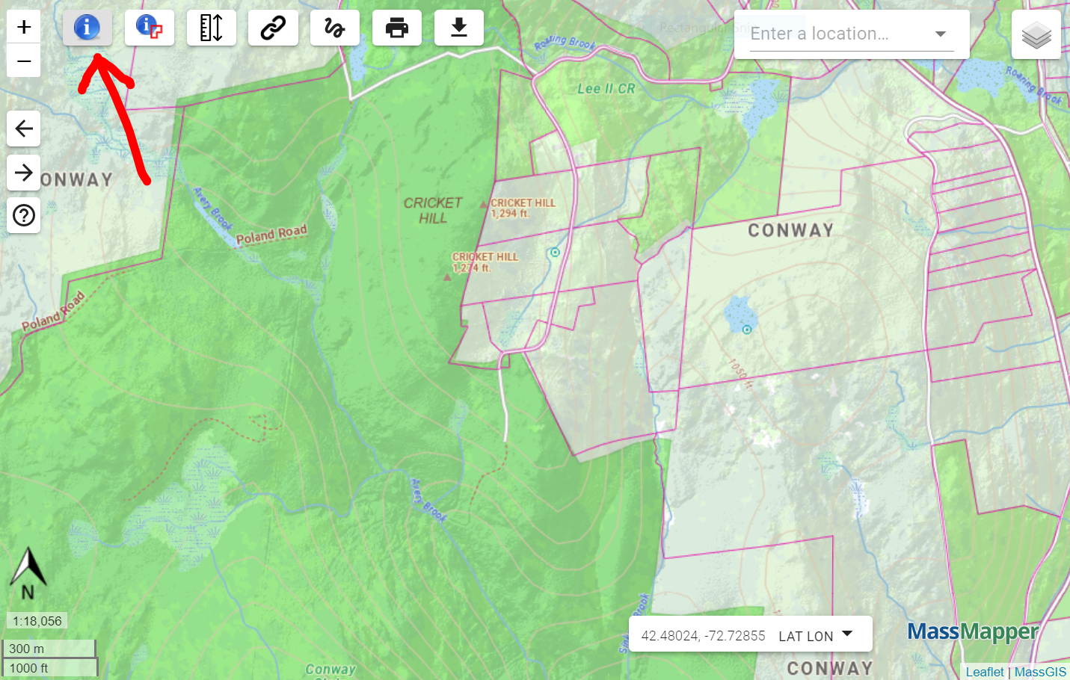

A box will appear with two Data Layer Names. Even if the Potential Vernal Pools has “0 features found”, that’s okay! Just double check that the property you have clicked on contains a potential vernal pool symbol. Unless you click directly on the pool, it will not identify it as a feature found, even if you’ve clicked on a property with a potential pool on it. Click into Property Tax Parcels, and info about that data layer will pop up. Scroll to the right until you see ownership info. You can mouse over info that is cut off and the full information will display. You can also click on “Save selected features as...” to download the file in a more readable format (excel).

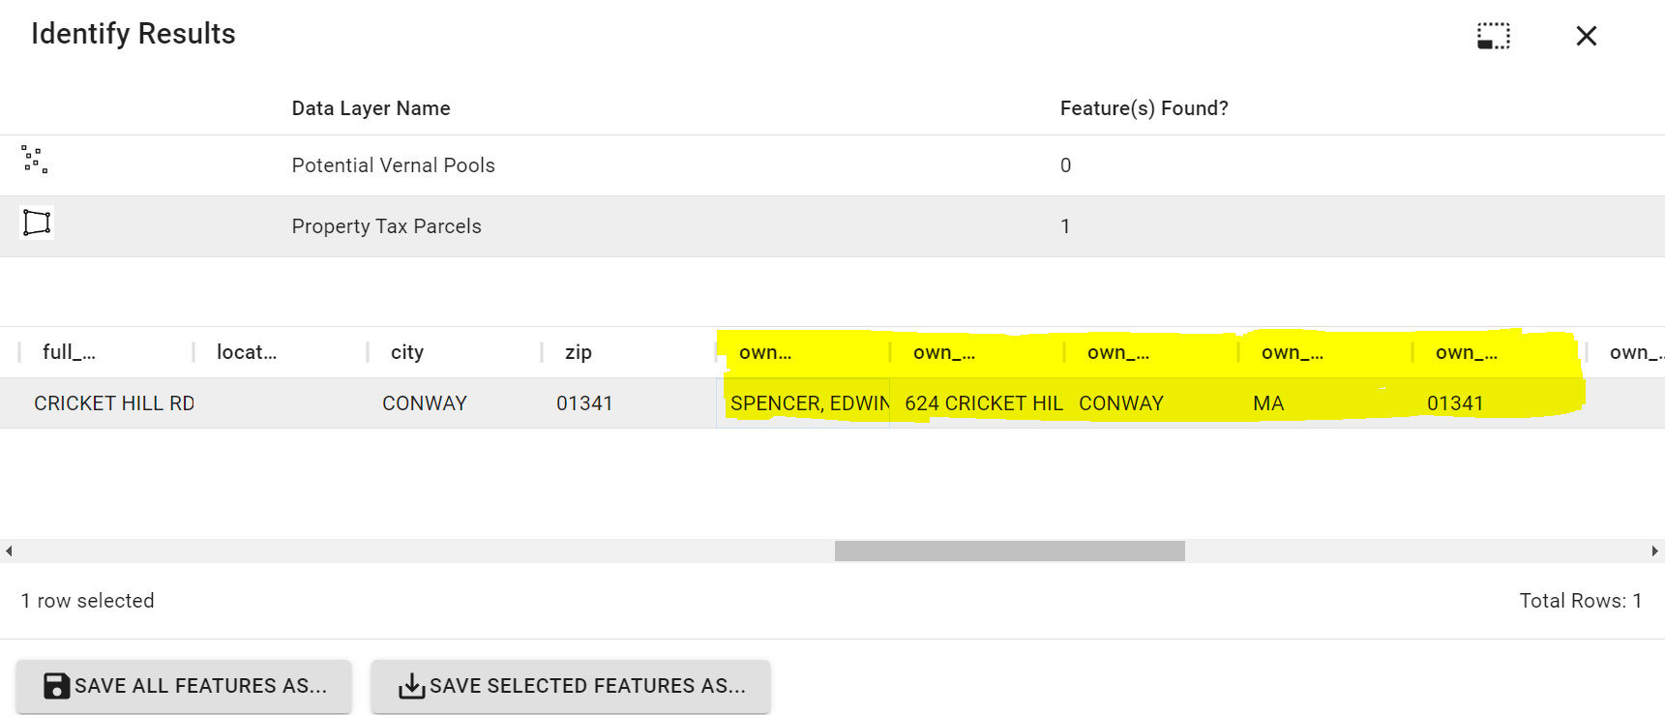

* If needed, GPS coordinates are available on the bottom of the map. If you hover over a potential vernal pool, it will give you the coordinates. However, these are not always perfectly accurate, and should be used as a guide.